# SCM 651 – Business Analytics

# Prof. Donald Harter

# Team #5

-Pranay Lulla

-Harsh Takrani

-Romil Godha

- Vijeth Vijaykumar

-Vaibhav Nigam

**Question 1: Goals:**

1. **What is your goal?**

Through the years, Whitman School of Management has aimed to recruit exceptional students. For this assignment, we are provided with dataset of GMAT (entrance examination for getting admission to Whitman School of Management). Our aim is to set a recruiting strategy for 2018-2019 campaign that would allow excellent applicants an opportunity to get admitted into this business School. This would enhance Whitman’s reputation in the long run. Whitman also aims at getting better placement rate and this could be achieved by getting excellent students to join their school. Further, we aim to devise a recruiting strategy that fits into a budget and the expenses are worth the quality and quantity of students that enroll in Whitman School of Management. One of the goals is also to formulate an itinerary in such a way that the budget is optimized.

1. **How do you plan to achieve your goal? What are the steps?**

Our team has come up with a stepwise procedure to achieve the goal. Firstly, we analyzed the given data set and filtered the data according to highest average GMAT score versus continents, countries and cities in order to target prime quality students. For the filtering, we have used the available dataset with priority for 2013-17 data, so that the trends are more consistent. Then, we targeted the countries that have minimum average GMAT score of 550. This enabled us to further filter out cities in those countries and find out cities that have low awareness of Whitman School of Management. After that, we focused on the cities in which Whitman School hosted seminars in but did not get good response (using the historic data provided), or even if they did, not many students met the Whitman alumni personally. Even if students met the alumni individually, how many of them applied to the University and how many of them got an admit and accepted the admit. The last step was to analyze that the students who accepted the admit, did enroll in Whitman or not, if not, then why? After analyzing all this, we came up with a plan to devise a tour in such a way that we target the accurate audience and host the events accordingly. Also, we extracted data from given links in the database to get the budget information and strategize accordingly.

1. **How will you measure success? Be specific about measures**

The ultimate success is measured by getting more number of brilliant candidates into Whitman School of Management. The measures to achieve this result are numerous:

* To get a better return on investment
* To get more applicants attracted towards the events hosted throughout the tour.
* To get those students to attend the personal interactive sessions hosted by alumni of Whitman.
* To get more students with good profiles into the business school.
* To optimize tour pricing - booking tickets, hotels and including other expenses throughout the tour.
* To identify cities that makes the recruiting process effective by getting talented students to enroll in the business school
* To identify potential new cities with better recruiting opportunities

**Question 2: What factors are important in your decision process to select cities? Rank your top five factors and explain why each is important?**

1. **Number of test takers by country with GMAT scores greater than 550**

We decided to include GMAT test takers by country and create an insightful visualization showing the countries with highest number of test takers. The country with the higher number of GMAT test takers represents enhanced prospective students. This represents an opportunity for the university to select popular cities in the country with such prospects. Below are the top countries with the highest number of prospective students.

***China-43%***

***India-23%***

***Canada-9%***

***Germany-5%***

***United Kingdom-4%***

***Korea -4%***

***Taiwan-4%***

***Rest- 8%***

China, India, Canada, Germany emerge as the countries with the highest test takers based on historical data. We then select countries based on their ***GMAT scores***. Average GMAT scores of the countries being pursued indicates the quality of the talent pool and provides us better insights on further narrowing down the countries to be targeted from the initial list of countries.

1. **Costoftours**: We then select cities based on proximity with each other and the expected cost calculated in our itinerary table to optimize budged within $100,00
2. **Number of people who attended the fair**: Among the countries of interest, we see that we have previous data available of fairs conducted. We then analyze this data to decide the cities to be included in our recruiting campaign tour. We have considered our third factor to be- ***Number of people who attended the fair***. This is because the higher the number of people who attended, the higher is interest in Whitman School of Management programs.

|  |  |  |  |  |  |
| --- | --- | --- | --- | --- | --- |
| **Fair attendance statistics for top cities** | **2013-14** | **2014-15** | **2015-16** | **2016-17** | **2017-18** |
| **Shanghai(China)** | 351 | 324 | 328 | 278 | 278 |
| **Beijing(China)** | 319 | 240 | 220 | 187 | - |
| **Bangalore(India)** | 765 | 526 | 488 | 361 | 436 |
| **Delhi(India)** | 637 | 658 | 537 | 518 | 493 |
| **Mumbai(India)** | 762 | 676 | 569 | 556 | 500 |
| **Chennai(India)** | 352 | 233 | 196 | 161 | - |
| **Taipei(China/Taiwan)** | 280 | 245 | 235 | 193 | - |
| **Kolkata(India)** | - | 143 | 154 | 92 | - |

1. **Total number of people who have applied in the courses in selected cities**:

This table extracted from the available data provides valuable insights into the success of the conducted fairs. We can see that selected cities except for Shanghai have a respectable number of applicants.

|  |  |  |  |
| --- | --- | --- | --- |
| **Cities** | **2013-14** | **2014-15** | **Total** |
| **Tour of Shanghai** | 0 | 0 | 0 |
| **Tour of Bangalore** | 7 | 5 | 12 |
| **Tour of Delhi** | 2 | 1 | 3 |
| **Tour of Mumbai** | 2 | 4 | 6 |
| **Tour of Beijing** | 2 | 5 | 7 |
| **Tour of Chennai** | 2 | 1 | 3 |
| **Tour of Kolkata** | - | 1 | 1 |
| **Tour of Taipei** | 3 | 1 | 4 |

1. The 5th factor in our selection is **the presence of state department offices/Education USA offices**. Presence of such offices in cities encourages students to apply and increases the confidence of students for selection United States of America as their preferred destination of study.

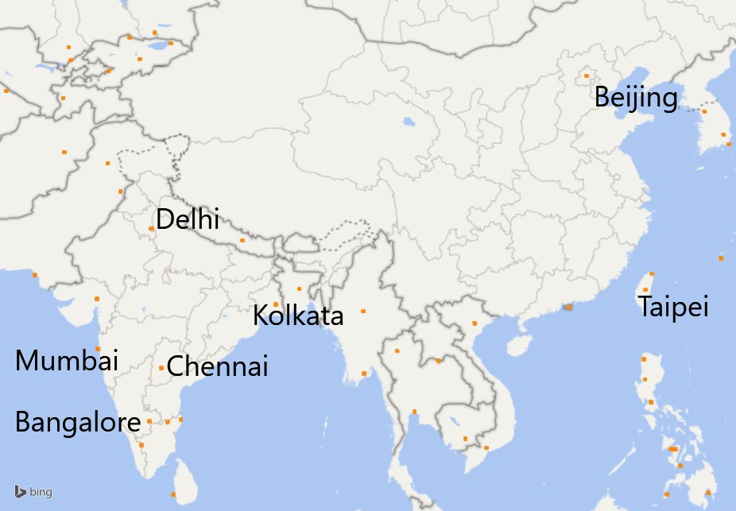

**Question 3: What trends do you detect?**

**a. By continent (Europe, Africa, North America, South America, Asia, India, Middle East)?**

For the continent analysis, we have taken into consideration AVG GMAT Score. So, we focus on continents that have a increasing GMAT scores- Europe, North America, Asia, keeping in mind the number of test takers are sufficient enough to consider that continent as well. Considering the factors mentioned above and by analyzing the given data, our team decided to focus on continents that have an increasing graph and are mentioned below:

1. Europe
2. North America
3. Asia

**b. By country?**

Based on the attached screenshot of ,maps data, we have created a visualization which shows countries which have an increasing trend of GMAT test takers. The countries in green have a positive trend of test takers in 2017.  The countries in yellow have a positive trend in 2016, purple 2015 and orange 2014. We have then analyzed the countries with higher number test takers and high GMAT scores and created a trend line to analyze the trends of GMAT scores with top countries.

Our team has used number of test takers to find the trend of test takers amongst countries, but we have used filtered data based on AVG GMAT score of years from 2013-2017, considering the minimum score of 550. So, the team came up with top 10 countries and of which top 3 were selected for city analysis. The countries are, China, India and Canada and the trendline is compiled in excel sheet.

1. **By city?**

Firstly, our team considered top 10 cities where the fairs hosted have maximum number of attendance, because if we consider all the cities in the data that would not help us clearly identify the trends. Then, we made bar graph of students who attended the fair held in those cities from 2013-2017. We noticed a trend that the number of students attending the fair have been decreasing every year. This clearly indicates that the management is not quite accurate in scheduling fair, approaching students or sending out invitations. There may also be a possibility that the speeches or knowledge being shared at those fairs is not what the students are looking for.

**Question 4: Quantify the marketing funnel**

1. **How many potential students are there? How many are there in the markets currently being pursued?**

For this, our team has created a marketing funnel in Excel based on recent GMAT data from 2013-2017. Potential students based on data of GMAT 2013 – 2017 are **584735** around the globe. This is the data including places where Whitman does not host career fair. Thus, these are the potential students of which some of them are pursued by Whitman and some of them are not. The number of potential students in the markets currently being pursued are **56878** i.e. the places at which Whitman conducts fairs.

1. **How many attended fairs? How many met with Syracuse recruiters?**

Number of students that attended fair are **23420** and number of students amongst this that met Syracuse recruiters are **1624**.

1. **How many students applied to Syracuse? How many enrolled in the fall?**

Students who applied to Syracuse during 2013-2017 were **49** and students who got enrolled in the end were **8**.

**Question 5:**

Using the 2017-2018 schedule as a baseline

1. **Which two cities visited in 2017-2018 would you drop if your budget were reduced?**

If the budget were to be reduced, the two cities that we would drop is Taipei and Jakarta. This is because Taipei is in Taiwan and Jakarta is in Indonesia, which have relatively small number of GMAT test takers and comparatively low-test scores. It also consumes additional expenses to travel to Taipei and Jakarta to conduct events. Also, having low interest rates of representatives. Overall the amount of expenses doesn’t result in a good value-added benefit for Syracuse University.

* Jakarta has a decrease in number of registered people from 2016-2017.
* Jakarta has a decrease in number of attended people from 2016-2017.
* It has a decrease in attended/registered people from 2016-2017.
* There is also a decrease in response rate from 2016-2017.

1. **Which two new cities would you add if your budget were increased?**

Two cities which would be included if the budget were to be increased are:

1. **Toronto**

This city is present in Canada, which is ranked third in Average GMAT scores. Also, they have the third highest test takers. This proves a good set of potential candidates. Therefore, this city has been included in the budget. Additionally, they are present close to Syracuse. So. the cost for travel and events will be comparatively low. This provides high potential to allow recruiters to attract good candidates for the University.

1. **Hong Kong**

This city has extremely good scores. Also, there is a trend of increasing scores over the years. If there is an increase in budget, then this becomes a good city with potential candidates. The cost for travel can be managed in itinerary from Taipei.

**Question 6:**

**Justify why you selected this set of cities**

The reason for selecting these cities are listed below:

* The difference between the number candidates who registered for the fair and who showed up is the least for these cities.
* Along with low difference in registered and accepted applicants, the registered/attended percentage is also high for these cities.
* The favorability (responsiveness/invited) is also high for the selected cities.
* The responsiveness percentage for these cities is the highest among all the top twenty cities.
* Data is consistent for these cities.

**Question 7:** Identify the costs and staffing for recruiting tours

1. **Event costs (registration)**

There are various categories of number of events as referred from the MBA brochure. Now, assuming the number of events to be 15 in India, this amount falls under 20% discount. Calculating the total cost after applying the discount would be $33,000. Similarly, total number of events in China and Canada is 14. Total number of Events for the entire tour would be 29. Total cost of events in India, China and Canada is $63,250.

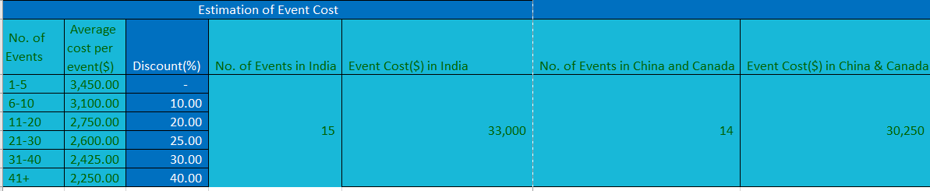

1. **How many recruiters or other people should be in each city (limit 4)? Justify your answer.**

The number of recruiters/ city are decided by assuming that 90-100 students will be attended by one recruiter. Hence, the distribution of recruiters is based on the total number of students attended the fair. Also, the recruiters assigned is based on the number of cities in a country selected.

1. **Travel costs (hotel, airfare, meals, cabs, airport parking in Syracuse)**

Similarly, the rates are calculated by considering the number of recruiters assigned to visit that city. For instance, number of students attended the fair in Mumbai is 556, therefore the number of recruiters in Mumbai would be 4. Also, observing the trend from the year 2013-2017, the number of students who attended the fair has decreased. Considering this can give an extra recruiter for meetup confirmations. 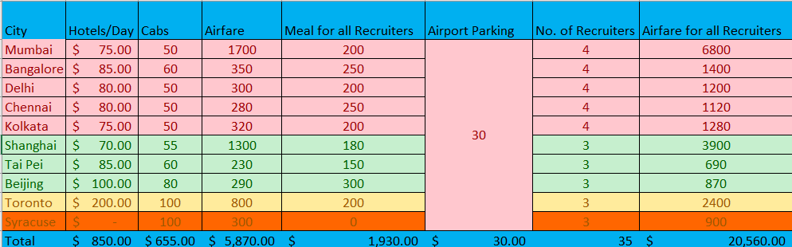

Airfares are based on itinerary. Firstly, the airfare is from Syracuse to Mumbai then the airfares are calculated from Mumbai, Bangalore, Delhi, Chennai, Kolkata respectively.

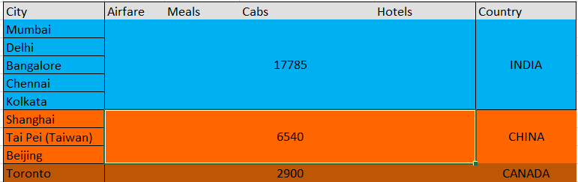

Similarly, for China airfare is from Syracuse to Shanghai. Meal and Cab rates are based on the number of recruiters. Airport parking is the parking rate at Syracuse Airport.

**Question 8:** The factors that could be considered as important apart from cab, meals, parking and hotel fares:

1. Cost of hiring the place for recruiting event.
2. Recruiters must be full time and must have extensive knowledge about the field and the University.
3. Feedbacks of the students for the event.
4. Feedbacks of the students for the recruiters.
5. School Presentations.
6. Audio & Visual event setup. To get in depth cost charting of the events.
7. The MBA tour match.
8. Cultural Events.

**What other data would help in developing a strategy, if you could collect it?**

* The data that could be considered apart from the given data:
* The budget of university should be provided for each city. The total spending of previously held events should be provided in a separate dataset. This could help in selecting hotels, fairs, meals and number of recruiters that should be assigned for each city.
* City wise data of GMAT exams such as No. of test takers, Average GMAT score etc. Since, this could help in predicting the number of potential cities where the events can be held successfully with more number of applications.
* A comprehensive list of admits and rejects and corresponding countries of applicants would help us determine the general trend about the quality of the candidates more accurately.

## **References:**

* [www.expedia.com](http://www.expedia.com)
* [www.uber.com](http://www.uber.com)
* Google Maps
* [www.google.com](http://www.google.com)
* [www.trivago.com](http://www.trivago.com)
* MBA Tour Mobile App